HDI Prediction and Analytics System

An Internship Project Report
Submitted to the Faculty of Engineering of
JAWAHARLAL NEHRU TECHNOLOGICAL UNIVERSITY KAKINADA
In partial fulfillment of the requirements for the award of the Degree of

BACHELOR OF TECHNOLOGY
in
ARTIFICIAL INTELLIGENCE AND DATA SCIENCE
By
Madireddy Meena Mahanth Harinadh
23481A5498

Under the guidance of
Dr. Battina Srinuvasu Kumar M.Tech., Ph.D. postdoc(SIT)
Professor & Mentor


DEPARTMENT OF ARTIFICIAL INTELLIGENCE AND DATA SCIENCE
SESHADRI RAO GUDLAVALLERU ENGINEERING COLLEGE
(An Autonomous Institute with permanent affiliation to JNTUK, Kakinada)
SESHADRI RAO KNOWLEDGE VILLAGE
GUDLAVALLERU 521356, ANDHRA PRADESH
2026–2027

SESHADRI RAO GUDLAVALLERU ENGINEERING COLLEGE
(An Autonomous Institute with permanent affiliation to JNTUK, Kakinada)

DEPARTMENT OF ARTIFICIAL INTELLIGENCE AND DATA SCIENCE

CERTIFICATE
This is to certify that the project report entitled “HDI Prediction and Analytics System” is a bonafide record of work carried out by Madireddy Meena Mahanth Harinadh (23481A5498) under the guidance and supervision of Dr. Battina Srinuvasu Kumar, M.Tech., Ph.D. postdoc(SIT), Professor & Mentor, in partial fulfillment of the requirements for the award of the degree of Bachelor of Technology in Artificial Intelligence and Data Science of Jawaharlal Nehru Technological University Kakinada, during the academic year 2026–2027.

Project Guide Head of the Department Dr. Battina Srinuvasu Kumar Dr. S. Narayana

ACKNOWLEDGEMENT

The satisfaction that accompanies the successful completion of any task would be incomplete without the mention of people who made it possible and whose constant guidance and encouragement crown all the efforts with success.
We would like to express our deep sense of gratitude and sincere thanks to Dr. Battina Srinuvasu Kumar, M.Tech., Ph.D. postdoc(SIT), Professor & Mentor, Department of Artificial Intelligence and Data Science for his constant guidance, supervision and motivation in completing the project work.
We feel elated to express our floral gratitude and sincere thanks to Dr. S. Narayana, Head of the Department, Artificial Intelligence and Data Science for his encouragements all the way during analysis of the project. His annotations, insinuations and criticisms are the key behind the successful completion of the project work.
We would like to take this opportunity to thank our beloved principal Dr. B. Karuna Kumar for providing a great support for us in completing our project and giving us the opportunity for doing project.
Our Special thanks to the faculty of our department and programmers of our computer lab. Finally, we thank our family members, non-teaching staff and our friends, who had directly or indirectly helped and supported us in completing our project in time.

By
Madireddy Meena Mahanth Harinadh
23481A5498

INTERNSHIP COMPLETION CERTIFICATE

Certificate issued by the internship organizers

Certificate particulars
Participant: Madireddy Meena Mahanth Harinadh
Registered hall ticket number: 23481A5498
Program: Artificial Intelligence and Machine Learning
Duration: Two months, 120 hours
Certificate ID: VIP-AIML-2026-3941
Issue date: 03 August 2026 Mode: Virtual
Organized by SmartBridge Educational Services Pvt. Ltd. in collaboration with the Andhra Pradesh State Council of Higher Education.

ABSTRACT
The HDI Prediction and Analytics System is an educational web application for exploring human-development observations, estimating the Human Development Index from its component indicators and comparing hypothetical scenarios. The project combines a reproducible regression experiment with an interactive interface that distinguishes published data, model estimates, formula-based calculations and optional AI explanations.
The prepared UNDP Human Development Report 2025 snapshot contains 5,940 complete country-year observations for 193 countries and territories, covering 1990–2023. Four inputs are used: life expectancy, expected years of schooling, mean years of schooling and gross national income per capita in constant 2021 PPP dollars. Income is transformed with the natural logarithm; no input imputation or feature scaling is used during inference.
Candidate regressors are compared using country-separated validation. Linear regression is selected by minimum validation mean absolute error, refitted on development countries and evaluated on held-out countries. The recorded test MAE is 0.004404, RMSE is 0.006670 and R² is 0.998183. The direct HDI formula is retained as an important reference because the target index is mathematically defined from the same indicators.
A React and TypeScript frontend provides historical exploration, validated predictions, scenario comparison and methodology views. Shared JavaScript evaluates the exported model in the browser and API. Optional Groq explanations use a visitor’s personal key held in active-tab memory. Numerical tools remain available without AI.
Verification includes numerical parity, API tests, browser workflows and a production build. The system demonstrates transparent index reconstruction; it does not establish future forecasting accuracy, causal policy effects, hosted performance or live-provider availability. The website is deployed on Vercel.
Keywords: Human Development Index, regression, country-separated validation, explainable analytics, scenario comparison, personal-key AI.

INDEX
TITLE PAGE NO
CHAPTER 1: INTRODUCTION 1
1.1 Project overview 1
1.2 Purpose and objectives 1
1.3 Scope of the study 1
1.4 Benefits and limitations 1
CHAPTER 2: IDEATION PHASE 3
2.1 Problem statement 3
2.2 Empathy map 3
2.3 Brainstorming and prioritization 3
2.4 Dataset and indicator definitions 3
CHAPTER 3: REQUIREMENT ANALYSIS 5
3.1 Customer journey 5
3.2 Functional requirements 5
3.3 User stories 7
3.4 Technology stack 8
CHAPTER 4: PROJECT DESIGN 9
4.1 Problem and solution fit 9
4.2 Proposed solution 9
4.3 Solution architecture 10
4.4 Data flow and state design 11
4.5 Mathematical formulation of HDI 11
4.6 Regression model and worked example 12
4.7 Evaluation and explanation equations 13
4.8 Model development and selection 14
CHAPTER 5: PROJECT PLANNING AND SCHEDULING 15
5.1 Work breakdown 15
5.2 Priorities and risk management 15
CHAPTER 6: FUNCTIONAL AND PERFORMANCE TESTING 16
6.1 Verification and functional testing 16
6.2 Model evaluation results 17
CHAPTER 7: RESULTS 18
7.1 Home and navigation 18
7.2 Reading the outputs 18
7.3 Published data exploration 19
7.4 Historical trend visualization 20
7.5 HDI prediction 21
7.6 Scenario comparison 22
7.7 Methodology and transparency 23
7.8 Personal AI settings and mobile use 24
CHAPTER 8: CONCLUSION AND FUTURE SCOPE 25
8.1 Conclusion 25
8.2 Future scope 25
CHAPTER 9: APPENDIX 26
9.1 Project links 26
9.2 Reproducing the application 26
9.3 Deployment configuration 26
9.4 References and evidence 27
9.5 Program outcomes 27
9.6 Project proforma 29
9.7 Outcome mapping 29

CHAPTER 1: INTRODUCTION

1.1 Project overview
Human development concerns people’s opportunities to live healthy lives, acquire knowledge and achieve a reasonable standard of living. The Human Development Index combines these dimensions into a comparable summary measure. A country’s income alone cannot explain its full development profile.
The HDI Prediction and Analytics System provides a public website for exploring published country observations, estimating HDI from four validated indicators, comparing hypothetical scenarios and reading optional AI explanations. The interface is branded HDI Intelligence and includes Home, Explore Data, HDI Predictor, Scenarios and Methodology pages. The deployed website is available at https://hdi-intelligence.vercel.app/ and the source code is available at https://github.com/meenamahanth/HDI-Prediction-Analytics-System.

1.2 Purpose and objectives
1. Present published country-year data with clear units, sources and missing-data states.
2. Reconstruct HDI using an evaluated regression model and display the direct formula as a separate reference.
3. Compare baseline and scenario inputs using the same trained estimator.
4. Make model selection, held-out evaluation and limitations understandable.
5. Offer optional Groq explanations without requiring a shared owner API key.

1.3 Scope of the study
The project is an educational application of regression and responsible data presentation. It uses a fixed UNDP HDR 2025 snapshot containing complete observations from 1990 to 2023. Estimates use indicators for the same observation year. The system is not a forecast of future national development and does not estimate the causal effect of policy interventions.

1.4 Benefits and limitations

Benefits
Numerical inference runs in the browser after the model loads, so ordinary exploration, predictions and scenarios do not require an account, database or continuously running Python service. Exact-value tables accompany visualizations, and exported JSON retains the values associated with the selected state.
The application separates published observations, model estimates, the formula reference and AI-generated prose. This distinction helps users understand what each number represents. Transparent model parameters and a shared inference implementation make the numerical behavior reproducible across the browser and API.

Limitations
1. A national average does not describe inequality within a country or every aspect of well-being.
2. Complete-case selection can favor countries and years with better reporting coverage. Historical revisions are part of the source snapshot.
3. High reconstruction R² partly reflects the fact that HDI is defined from the same component indicators.
4. A valid numerical input range does not guarantee that every indicator combination is realistic or well represented in training data.
5. Scenarios and feature sensitivity describe model responses, not causal policy outcomes.
6. Groq explanations require network access and a valid personal key; they may be unavailable or incorrect.

Intended users
Students can examine how the index is constructed. Educators can demonstrate evaluation and model limitations. Analysts can inspect published observations and compare input combinations. The system is not designed to make official allocation, lending, eligibility or policy decisions.

CHAPTER 2: IDEATION PHASE

2.1 Problem statement
Published development tables contain valuable evidence, but readers often need to move between data files, definitions and separate calculation tools. Comparing two countries through time, understanding an index value and testing a hypothetical combination of indicators can therefore require several disconnected steps.
The proposed solution brings these tasks into one interface while preserving their different meanings. Country comparisons use published records; estimates and scenarios use validated inputs; the official formula remains visible; and optional explanations are grounded in numerical context recomputed by the server.

2.2 Empathy map
Table 1 User needs and interface responses
Perspective | User need | Design response
Says | “What does this HDI value mean?” | Explain dimensions, units and categories.
Thinks | Can I trust the comparison? | Show source, year and exact values.
Does | Changes countries and indicators. | Update plots and validate drafts.
Feels | Uncertain about complex models. | Show formula, metrics and limits.

2.3 Brainstorming and prioritization
The chosen priorities were reliable data, numerical correctness and a readable public interface. Historical exploration and scenario comparison were retained because they connect source observations to understandable questions. AI was made optional so that provider failures cannot prevent core numerical work.
Features such as accounts, persistent prediction history, an administrator dashboard and automated policy recommendations are outside the current implementation. Prioritizing a small set of verifiable workflows keeps the project maintainable and limits unsupported claims.

2.4 Dataset and indicator definitions
The active dataset is the UNDP Human Development Report 2025 composite-index time series. Preparation retains country or territory records with three-letter ISO codes and published country ranks, then selects rows containing all four model inputs and the HDI target. Regional aggregates are excluded.
Table 2 Prepared dataset summary
Property | Recorded value
Complete country-year observations | 5940
Countries and territories | 193
Observation years | 1990–2023
Excluded incomplete country-years | 622
Target | Published HDI on a 0 to 1 scale
Source release | UNDP Human Development Report 2025

Table 3 Input variables
Indicator | Meaning | Unit
Life expectancy | Expected lifespan at birth | Years
Expected schooling | Schooling expected for a child entering school | Years
Mean schooling | Average completed schooling for adults aged 25 and older | Years
GNI per capita | Gross national income per person | Constant 2021 PPP dollars

Raw values retain their precision during training. The interface labels rounded presets, while computations use the current validated inputs. Missing observations are not replaced with fabricated zeroes, and historical gaps remain gaps in the plot.
The source is a fixed, versioned snapshot rather than a live feed. Published estimates and retrospective revisions must be considered when interpreting trends. Complete-case filtering and cross-country dependence remain limitations of the experiment.

CHAPTER 3: REQUIREMENT ANALYSIS

3.1 Customer journey
1. Open Home and review the three HDI dimensions and published summary.
2. Choose a country, comparison country, observation year and region in Explore Data. Inspect the plot, exact-value table and source.
3. Load a published preset into HDI Predictor or enter four indicators. Correct invalid values before calculating.
4. Read the model estimate, category, formula reference and dimension indices. Export the result if needed.
5. Open Scenarios, edit indicators and compare the new estimate with the committed baseline. Reset to restore it.
6. Review model evidence on Methodology. Configure a personal key only if an AI explanation is wanted.

3.2 Functional requirements
The following are the functional requirements of the proposed solution.
Table 4 Functional requirements
FR No. | Functional Requirement (Epic) | Sub-Requirement (Acceptance Condition)
FR-1 | Published-data exploration | Filters, tables and exports describe the same selected records.
FR-2 | Validated prediction | Missing, nonfinite and out-of-range inputs cannot produce a valid result.
FR-3 | Scenario comparison | Both states use the same model; reset restores an exact baseline match.
FR-4 | Historical visualization | Real observations render; gaps and single-point cases are handled.
FR-5 | Model transparency | Source, split method, metrics and limitations are accessible.
FR-6 | Personal-key AI | Keys remain in tab memory and are sent only for explicit AI requests.

Non-functional requirements
The following are the non-functional requirements of the proposed solution.
Table 5 Non-functional requirements
NFR No. | Non-Functional Requirement | Description
NFR-1 | Usability | Labeled inputs, keyboard focus, a compact navbar, a mobile menu, light and dark themes and exact-value alternatives to charts support usability. Reduced-motion preferences are respected. Automated accessibility checks support these aims but do not replace human evaluation across devices.
NFR-2 | Security | Personal keys are held in active-tab memory only and are not stored in local storage, URLs or exported results. The server receives a key only during the requested provider operation, so trusted hosting and HTTPS are required in production.
NFR-3 | Reliability | Explicit loading, empty, retry and error states are provided. A failed AI request leaves the numerical tools available, and the server recomputes numerical evidence instead of trusting a submitted prediction.
NFR-4 | Performance | Numerical inference runs in the browser after the model loads, using shared validation and inference logic. Production response-time targets and concurrency capacity have not been measured.
NFR-5 | Availability | Data exploration, prediction and scenario tools need no account, database or personal key; only the optional AI explanations depend on network access and the provider.
NFR-6 | Scalability | A static frontend with committed JSON artifacts and in-browser inference avoids a continuously running Python service. Distributed rate-limit behaviour and hosted concurrency require separate deployed-system measurements.

3.3 User stories
The user stories below describe the main needs of the intended users of this project.
Table 6 User stories
User Type | Functional Requirement (Epic) | User Story No. | User Story / Task | Acceptance Criteria
Student | FR-1, FR-4: Published-data exploration; Historical visualization | USN-1 | As a student, I want to compare countries through time. | Changing the selected year updates observed values and the displayed history.
Learner | FR-2, FR-5: Validated prediction; Model transparency | USN-2 | As a learner, I want to understand an estimate. | Model output and formula reference are labeled separately.
Analyst | FR-1: Published-data exploration (exact export) | USN-3 | As an analyst, I want an exact export. | Downloaded JSON agrees with the displayed input and observation state.
Visitor | FR-6: Personal-key AI | USN-4 | As a visitor, I want control of my API key. | Show, change, remove and refresh-clearing states behave as described.
Mobile user | NFR-1: Usability | USN-5 | As a mobile user, I want usable controls. | Navigation, charts, dialogs and tables remain accessible at narrow widths.

3.4 Technology stack
Table 7 Components and technologies
S.No | Component | Description | Technology
1 | User interface | Component-based public website and typed state. | React 19 and TypeScript
2 | Styling | Responsive cyan design, themes and focus states. | Tailwind CSS 4 and CSS
3 | Charts and icons | Historical plots, model evidence and interface icons. | Recharts and Lucide
4 | Build tools | Local development and production asset generation. | Vite 7 and Node.js 24.x
5 | Research workflow | Prepare data, compare regressors and export artifacts. | Python, pandas, NumPy, scikit-learn
6 | Inference | Apply validation, log transformation and trained coefficients. | Shared JavaScript module and JSON
7 | Optional AI | Generate explanations from server-recomputed context. | Groq through a Node function
8 | Verification | Numerical, API, static and browser checks. | Node tests, ESLint, TypeScript, Playwright
9 | Hosting target | Static frontend plus optional serverless endpoint. | Vercel

Table 8 Application characteristics
S.No | Characteristics | Description and Technology
1 | Open-source frameworks | React, Vite, Tailwind CSS, Recharts and Lucide for the interface; Python, pandas, NumPy and scikit-learn for the research workflow.
2 | Security implementations | Personal keys are held in active-tab memory only; the API checks method, content type, origin, credential format, body size, input schema and question length; environment files are excluded from publication.
3 | Scalable architecture | Static frontend with committed JSON artifacts, a shared inference module and an optional same-origin serverless endpoint.
4 | Availability | Numerical tools run in the browser without a key or provider access; the website is deployed on Vercel at https://hdi-intelligence.vercel.app/
5 | Performance | Shared local inference with exported coefficients; production response-time and concurrency targets have not been measured.

CHAPTER 4: PROJECT DESIGN

4.1 Problem and solution fit
The design separates evidence retrieval, numerical estimation and optional language generation. Static JSON supports published-data views. A small shared evaluator performs deterministic calculations. An optional server function validates AI requests and supplies recomputed context to Groq.

4.2 Proposed solution
Table 9 Proposed solution
S.No | Parameter | Description
1 | Problem statement | Published development tables, definitions and calculation tools are separate, so comparing countries through time, understanding an index value and testing a hypothetical combination of indicators takes several disconnected steps.
2 | Idea / solution description | A single website, HDI Intelligence, that explores published UNDP HDR 2025 observations, estimates HDI from four validated indicators with an evaluated linear regression model, compares baseline and scenario inputs, and offers optional Groq explanations.
3 | Novelty / uniqueness | Published observations, model estimates, the direct formula reference and AI-generated prose are shown as separate outputs; the formula stays visible beside the regression estimate, and AI explanations use a visitor’s personal key held in tab memory.
4 | Social impact / user satisfaction | Helps students, educators and analysts understand how the index is constructed and where its limits lie, using exact-value tables, sources and stated limitations.
5 | Business model | Educational project; no revenue model, account system or database is implemented.
6 | Scalability of the solution | Inference runs in the browser from static JSON, so ordinary use needs no continuously running Python service; hosted concurrency has not been measured.

4.3 Solution architecture
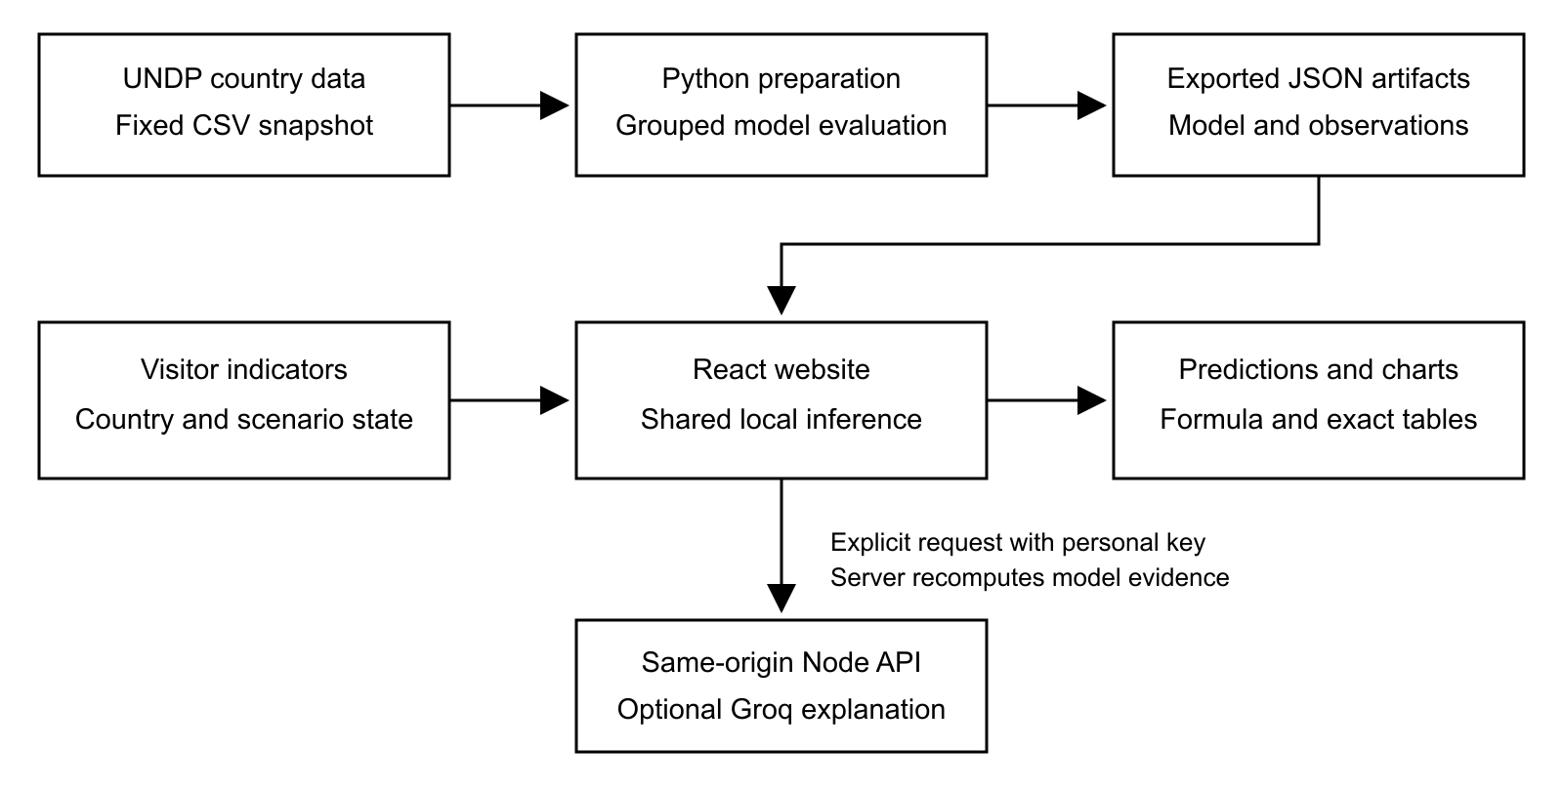
Figure 1 Architecture of the implemented HDI system

Component responsibilities
The frontend manages filters, draft inputs, a committed prediction baseline, scenario values, theme and temporary key state. The shared module validates input, computes the model result and implements the direct formula. Training scripts remain separate from request-time execution.
Only explicit AI operations contact the backend. Numerical results remain available without a key. The application has no current account database, persistent prediction history or administrator workflow. This separation reduces runtime complexity and makes the numerical path independently testable.

4.4 Data flow and state design
Table 10 Data entities and state boundaries
State or artifact | Contents | Lifetime
Country and historical records | ISO code, name, region, year and observed indicators | Committed public JSON
Model artifact | Feature order, coefficients, intercept, medians and ranges | Committed public JSON
Evaluation evidence | Splits, metrics, comparisons and residual samples | Committed public JSON
Draft prediction | Four values being edited | Current browser session
Baseline and scenario | Committed input and separate modified input | Current browser session
Personal Groq key | Credential and request status | Active tab memory only
Download | Selected observations or numerical result | User-requested local file

Calculation flow
The user enters or loads indicators. Validation rejects missing, nonfinite and out-of-range values. Valid GNI is transformed with the natural logarithm; the other three inputs are unchanged. The exported coefficients and intercept produce a model estimate, which is clipped to the interval from zero to one. The category uses full numerical precision.
Editing a draft does not silently replace an already calculated baseline. A stale-result notice indicates that recalculation is required. A scenario uses the committed baseline and independently edited indicators. Reset copies the baseline values back into the scenario.

AI request flow
The endpoint checks method, content type, origin, credential format, body size, input schema and question length. It computes the scores itself, bounds provider output and handles timeouts and provider errors. Key replacement or removal cancels pending browser work; it cannot recall a request already transmitted to the provider.

4.5 Mathematical formulation of HDI
Let L denote life expectancy, E expected years of schooling, M mean years of schooling and G gross national income per capita in constant 2021 PPP dollars. The direct reference follows the UNDP dimension goalposts [1]. The implementation bounds each component to the interval [0, 1].
 | $$c(z) = min(1, max(0, z))$$ | (1)
 | $$I_{health} = c(\frac{L - 20}{85 - 20})$$ | (2)
 | $$I_{expected} = c(\frac{E}{18}), I_{mean} = c(\frac{M}{15})$$ | (3)
 | $$I_{education} = \frac{I_{expected} + I_{mean}}{2}$$ | (4)
 | $$I_{income} = c(\frac{ln(G) - ln(100)}{ln(75000) - ln(100)})$$ | (5)
 | $${HDI}_{formula} = \sqrt[3]{I_{health} × I_{education} × I_{income}}$$ | (6)
The education dimension averages two distinct schooling indices. Income uses a natural logarithm. The final index is the geometric mean of the three dimensions. If a dimension is zero, the geometric mean is zero. The direct formula is a reference calculation; it is not the trained regression model.
Table 11 Development categories used by the interface
HDI range | Category
Below 0.550 | Low
0.550 to below 0.700 | Medium
0.700 to below 0.800 | High
0.800 and above | Very high

4.6 Regression model and worked example
The selected estimator is linear regression with a logarithmic income input. Feature order is fixed as L, E, M and ln(G). Coefficients are fitted on development-country data, then exported to JSON. No feature scaling or input imputation is performed during inference.
 | $$ŷ = c(β_{0} + β_{1}L + β_{2}E + β_{3}M + β_{4}ln(G))$$ | (7)
Table 12 Fitted linear model parameters
Parameter | Exported value
Intercept β₀ | -0.318330582979
Life expectancy β₁ | 0.004744564534
Expected schooling β₂ | 0.010960755672
Mean schooling β₃ | 0.013040583089
Log income β₄ | 0.046704851108

The table rounds coefficients for readability; the application retains their full exported precision. The coefficient on ln(G) means that equal absolute income changes need not produce equal model changes. Correlated inputs limit causal interpretation of all coefficients.

Illustrative calculation
For L = 70 years, E = 13 years, M = 8 years and G = 10,000 constant 2021 PPP dollars, the shared evaluator gives the following results. This is a numerical example, not a published country observation.
Table 13 Worked example evaluated by the project code
Quantity | Calculated value
Health dimension | 0.769231
Education dimension | 0.627778
Income dimension | 0.695637
Direct formula HDI | 0.695155
Regression HDI | 0.690771
Regression category | Medium

A difference between the formula and regression values is expected because regression approximates the index. When the defined components are available, the formula is the direct calculation.

4.7 Evaluation and explanation equations
For n held-out observations, let yᵢ be published HDI, ŷᵢ the clipped model prediction and ȳ the mean published HDI in that evaluation set. Error metrics are calculated on the same target scale.
 | $$MAE = \frac{1}{n}\sum_{i = 1}^{n}{\left|y_{i} - ŷ_{i}\right|}$$ | (8)
 | $$RMSE = \sqrt{\frac{1}{n}\sum_{i = 1}^{n}{{(y_{i} - ŷ_{i})}^{2}}}$$ | (9)
 | $$R^{2} = 1 - \frac{\sum_{i = 1}^{n}{{(y_{i} - ŷ_{i})}^{2}}}{\sum_{i = 1}^{n}{{(y_{i} - ȳ)}^{2}}}$$ | (10)
MAE summarizes average absolute error. RMSE gives greater weight to larger errors. R² compares squared error with variation around the evaluation mean; it is not a percentage accuracy score and does not prove forecasting ability.

Scenario comparison
 | $$ΔHDI = f(x_{scenario}) - f(x_{baseline})$$ | (11)
The difference is expressed in HDI points. Resetting to identical inputs yields zero difference. A positive change means a higher model estimate for the chosen combination, not a measured effect of an intervention.

Local feature sensitivity
 | $$S_{j} = f(x) - f(x_{j←median})$$ | (12)
For each feature j, the system replaces only that feature with its development-data median and recomputes the estimate. These one-feature replacement differences are not SHAP values, do not sum to the prediction and are not causal effects. Global permutation importance separately measures the increase in held-out MAE after shuffling one feature.

4.8 Model development and selection

Data preparation
The training workflow checks the official CSV snapshot, selects country records, reshapes the wide time series into a country-year panel and retains complete observations. Raw input precision is preserved. GNI per capita is transformed by the natural logarithm because the income component has diminishing increments on the HDI scale.

Country-separated evaluation
The outer grouped split uses ISO country codes and seed 42 to reserve approximately 20% of countries for testing. An inner grouped split with seed 43 reserves validation countries from the remaining development set. The same country cannot occur in more than one partition.
Table 14 Country-disjoint data partitions
Partition | Rows | Countries | Purpose
Training | 3611 | 115 | Fit candidate models
Validation | 1178 | 39 | Select minimum validation MAE
Test | 1151 | 39 | Evaluate the selected refit once

Candidate comparison
Linear regression, a decision tree, a random forest and Extra Trees were compared. Linear regression achieved the smallest validation MAE and was selected. The selected estimator was refitted on training plus validation countries before its final test evaluation. Test results were not used to select the model.

CHAPTER 5: PROJECT PLANNING AND SCHEDULING

5.1 Work breakdown
Project work follows the dependency order shown below: source verification precedes model evidence, and numerical verification precedes interface and deployment checks. The plan describes work packages and deliverables rather than assigning unsupported sprint dates.
Table 15 Work packages and deliverables
Work package | Deliverable | Completion criterion
Problem and scope | Objectives, users and boundaries | Separate observations, estimates and scenarios.
Data preparation | Pinned source and complete panel | Provenance, units and missing-data behavior documented.
Model development | Compared regressors and selected artifact | Country-disjoint validation and held-out evaluation recorded.
Inference and interface | Shared evaluator and public website | Validations, plots and workflows operate consistently.
Optional AI | Personal-key explanation endpoint | Origin, schema, credential and provider failures handled.
Verification | Automated checks and actual screenshots | Numerical, API and browser results recorded.
Documentation and release | Academic report and deployment guide | Links resolve; secrets and generated output excluded.

5.2 Priorities and risk management
Data fidelity and numerical correctness are high-priority dependencies. Missing observations, invalid inputs and misleading claims are controlled through explicit validation and labels. Optional AI is isolated so that service outages do not prevent the project demonstration.
Publication risks are addressed through ignored environment files, placeholder examples and inspection of files that Git would stage. Reproducibility risks are addressed through the lockfile, model JSON, source checksum and parity fixtures. Hosted performance, broader device review and provider availability remain checks for the deployed site.

CHAPTER 6: FUNCTIONAL AND PERFORMANCE TESTING

6.1 Verification and functional testing
The recorded final cleanup verification is dated 28 October 2026. It checks the existing implementation without retraining the model. Results are preserved in the repository verification record [3].
Table 16 Verification results
Check | Recorded result | What it establishes
Node numerical and API suite | 22 passed | Validation, model behavior, API errors and dependency isolation.
Python–JavaScript parity | 1,407 cases; max error 2.220446049250313 × 10⁻¹⁶ | Exported evaluator agrees within numerical tolerance.
Chrome functional suite | 11 passed | Navigation, charts, themes, mobile layouts, exports and key state.
Production Chrome check | 1 passed | Built assets, route refresh and offline numerical workflows.
TypeScript and ESLint | Passed | Static type and lint checks.
Production build | Passed; Vite 7.3.7 | Production assets generated successfully.
Protected scientific files | 11 unchanged | Required existing training, data and inference files retained.

Functional coverage
Checks cover observed data and exact exports, invalid indicators, scenario reset, visible chart drawing surfaces, missing-year states, same-country comparisons, mobile and keyboard controls, themes, and personal-key change, removal and refresh clearing. Provider success and failure are represented by explicitly injected test responses.

Interpretation of performance evidence
These results do not certify production throughput, latency, universal device accessibility or live-provider availability. No new live Groq call was performed during cleanup verification. The API isolation test checks local dependencies; it does not prove the contents of an actual Vercel function bundle.

6.2 Model evaluation results
Table 17 Validation comparison of regression candidates
Candidate | Validation MAE | Validation RMSE | Validation R²
Linear regression | 0.004148 | 0.005374 | 0.998855
Decision tree | 0.015369 | 0.020814 | 0.982815
Random forest | 0.007959 | 0.011751 | 0.994523
Extra Trees | 0.004209 | 0.005886 | 0.998626

Linear regression has the smallest validation MAE, narrowly ahead of Extra Trees. The model choice follows the recorded selection criterion rather than choosing the most complex algorithm. The following results use the selected model and separate reference calculations.
Table 18 Recorded final and reference metrics
Evaluation | MAE | RMSE | R²
Held-out countries | 0.004404 | 0.006670 | 0.998183
Direct formula on same rows | 0.000247 | 0.000286 | 0.999997
2019–2023 temporal diagnostic | 0.004257 | 0.006712 | 0.998006

Interpretation
The held-out MAE is approximately 0.0044 HDI points. The direct formula is substantially closer to published HDI because the index is defined from the same component indicators. Small formula discrepancies are consistent with publication rounding and source revisions. The comparison is therefore an important baseline rather than an implementation failure.
High R² describes reconstruction of a defined index. Country grouping reduces repeated-country leakage but cannot eliminate every cross-country dependency. No calibrated uncertainty interval or causal effect estimate is claimed.

Historical synthetic-data audit
An earlier synthetic experiment used noisy formula-based targets and related country families. A separate four-input comparator recorded MAE 0.004405 under a random row split and 0.010036 under a country-family split. This illustrates the effect of dependence; it is not the performance claim of the current official-data model.

CHAPTER 7: RESULTS

7.1 Home and navigation
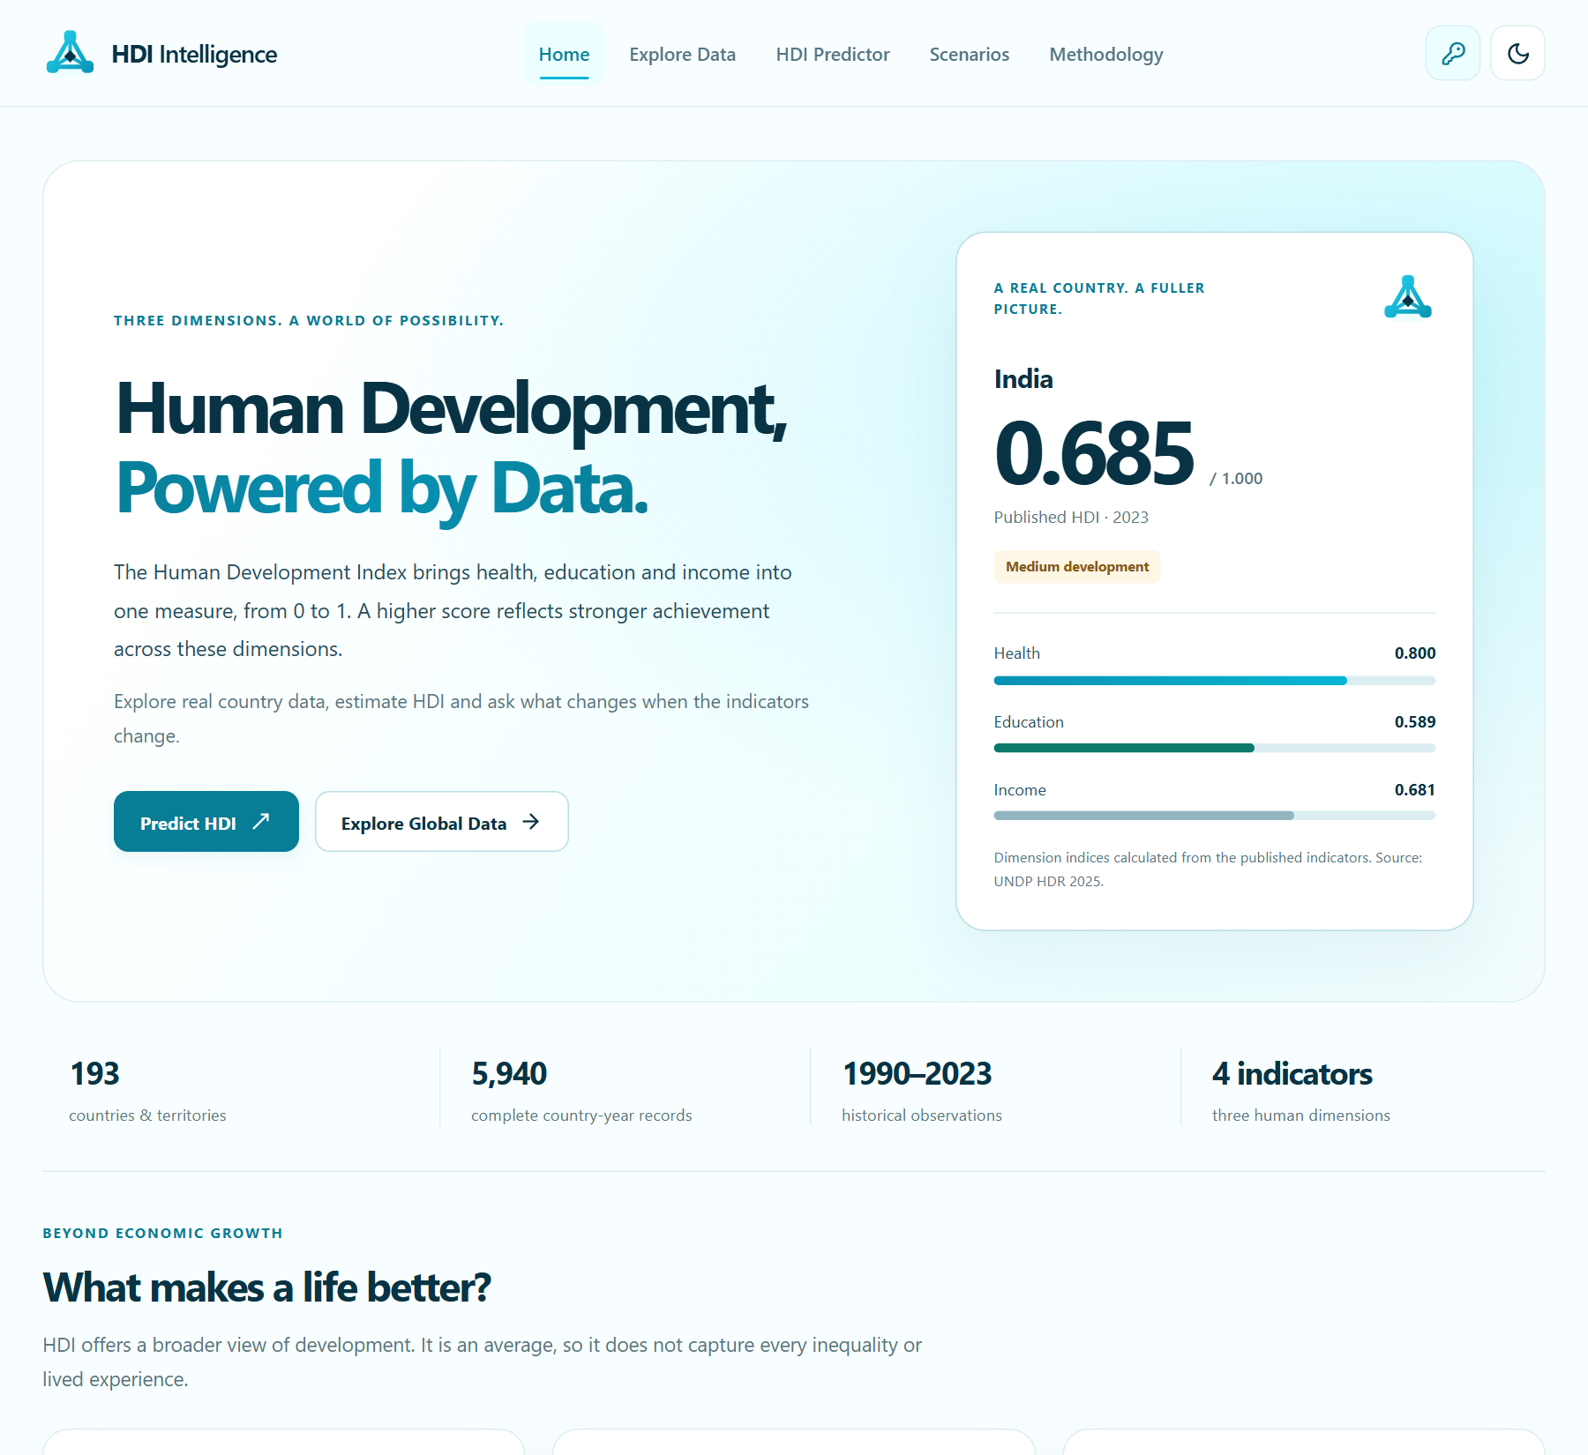
Figure 2 Home page with project identity and a published country summary
The home page introduces health, education and income, presents the published-data coverage, and links to exploration and prediction. A horizontal navbar and mobile dropdown expose the same main functions. The footer retains the project creator attribution.

7.2 Reading the outputs
Published HDI belongs to a selected country and year. A model estimate belongs to the current numerical inputs. A formula reference directly combines the dimension indices. These outputs must be described separately during a demonstration.
The results figures reproduce actual local application captures from the repository. They show interface states and numerical evidence; they do not establish that a new live Groq request has been verified.

7.3 Published data exploration
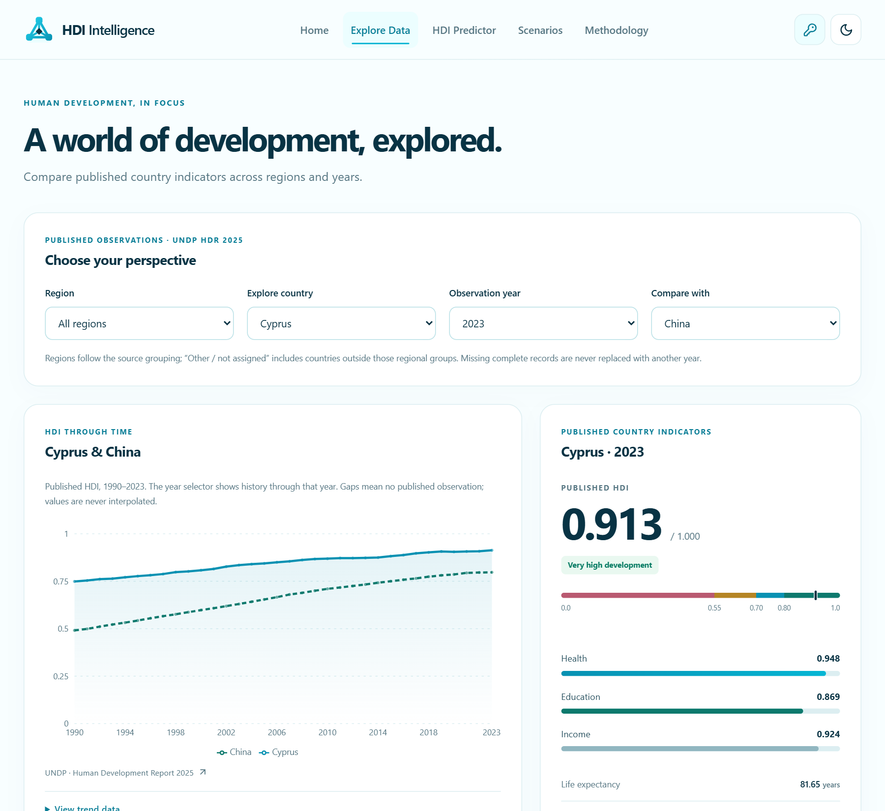
Figure 3 Explore Data with country filters and observed historical comparison
The exploration page supports country, comparison-country, year, region and category filters. Country summaries correspond to the selected observation. Exact-value tables and filtered JSON exports provide a numerical alternative to the visual presentation.
Changing the year changes both the displayed observations and the history shown through that year. Missing data is represented as unavailable. A missing observation must not appear as a fabricated zero or an interpolated record.
The country name and year help interpret observations and route presets; they are not additional predictors in the active regression model. Only the four validated component indicators enter inference.

7.4 Historical trend visualization
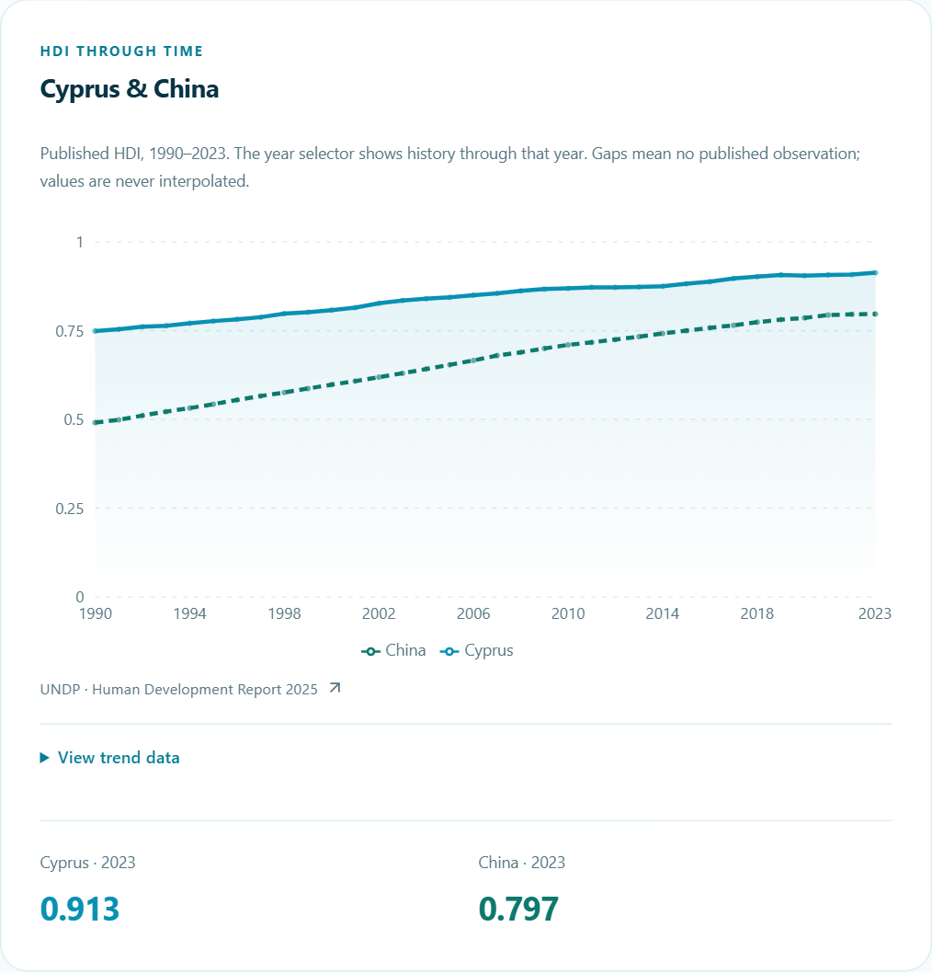
Figure 4 Observed Cyprus and China HDI history with source and exact values
The recorded comparison displays 34 published observations per country over 1990–2023. The source, legend and exact-value alternative accompany the chart. A single observation is shown as a point, missing calendar years remain gaps, and comparisons of the same country do not create misleading duplicate series.

Chart repair and verification
The earlier blank-plot defect occurred even though valid paths and data existed: a shared CSS maximum-width rule reduced the SVG drawing surface to zero. Removing that constraint restored a measured drawing width of approximately 691 pixels in the recorded desktop state. The data itself was unchanged.
Browser checks now inspect nonzero drawing surfaces across plots, mobile and desktop sizes, and both themes. This demonstrates why populated component data or a visible legend alone is insufficient evidence that a chart renders correctly.

7.5 HDI prediction
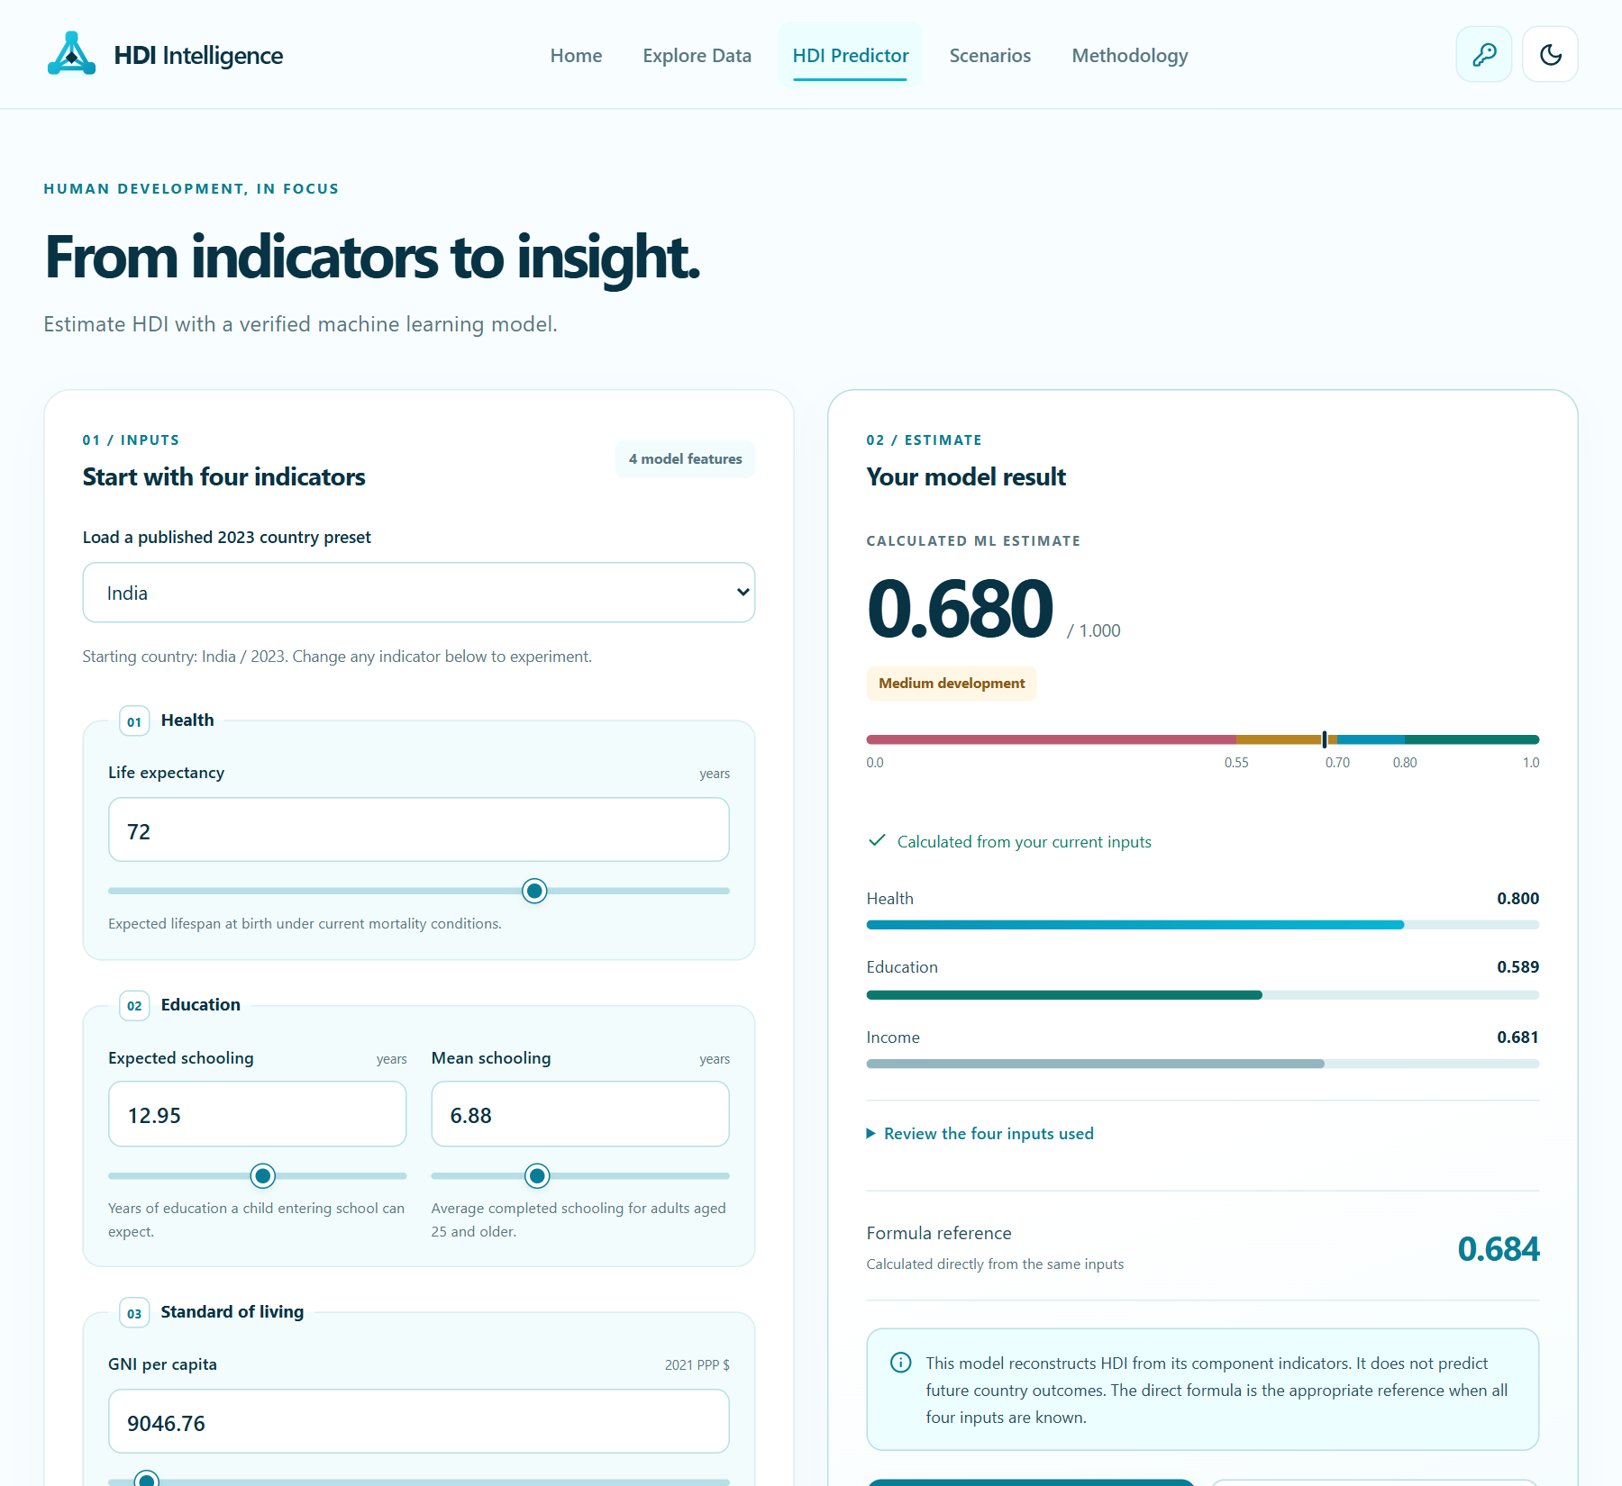
Figure 5 Predictor with validated inputs, a model estimate and formula reference
The predictor accepts life expectancy, expected schooling, mean schooling and GNI per capita. Users may load a published country-year preset or enter values directly. The interface validates bounds and warns about inputs outside the observed training range.
The captured example displays a regression estimate of 0.680 after rounding. The estimate, formula reference and dimension indices remain separately labeled. The result is calculated from the supplied indicators; it is not AI-generated text.
Editing an input marks the displayed result as stale until recalculation. Invalid inputs prevent a new estimate. Export records the committed calculation rather than silently substituting an unfinished draft.

7.6 Scenario comparison
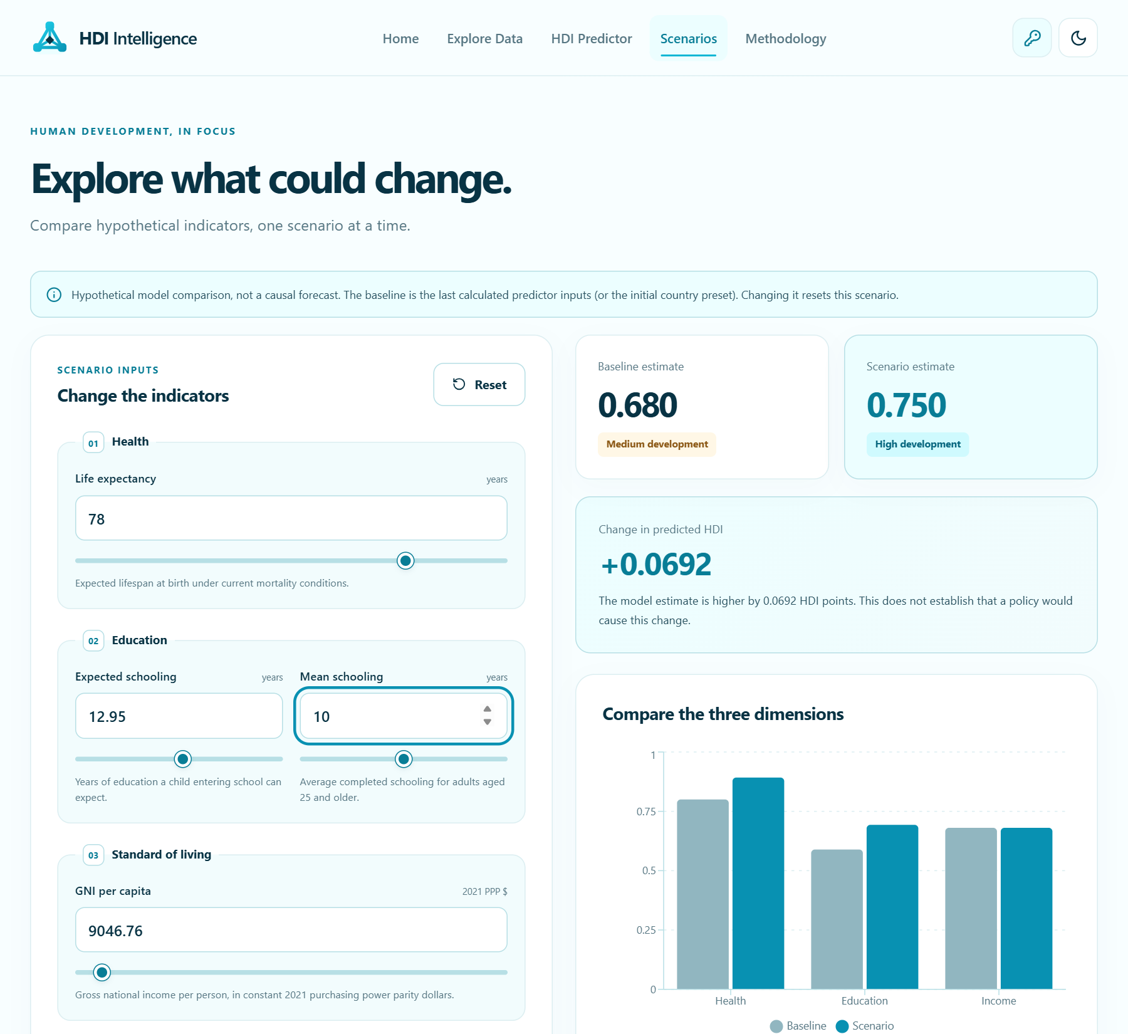
Figure 6 Baseline and scenario predictions with dimension comparison
Scenario analysis retains a committed baseline while allowing independent edits to the four indicators. Both predictions use the same model. The interface displays the HDI-point difference, compares dimensions and provides a reset action.
The captured scenario shows an increase of +0.0692 HDI points for its recorded indicator combination. This number is a model comparison, not evidence that a particular policy would cause the increase. Resetting the scenario to the baseline restores zero difference.
Because the income transformation is logarithmic and indicators can be correlated, equal-sized edits need not have equal estimated effects. Real-world feasibility and distributional consequences require analysis beyond this demonstration.

7.7 Methodology and transparency
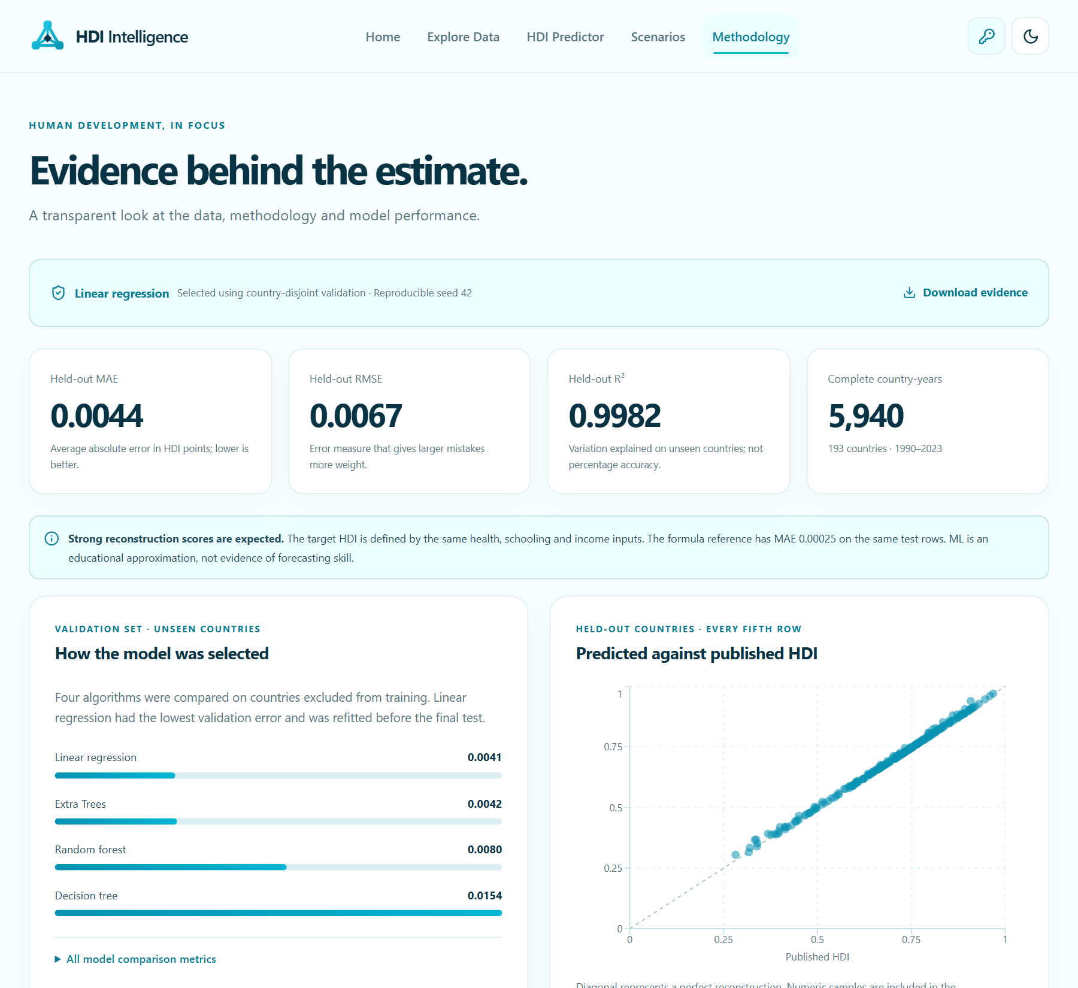
Figure 7 Methodology page with held-out metrics and prediction scatter
The Methodology page reports the prepared dataset, model comparison, country-separated split, held-out performance and limitations. A published-versus-predicted scatter plot visualizes recorded residual samples. The diagonal is a reference for agreement, not an uncertainty band.
Global permutation importance expresses the increase in held-out MAE after a feature is shuffled. Local sensitivity uses one-feature median replacement. Neither should be interpreted as the causal contribution of an intervention.
The existing scientific artifacts remain unchanged during documentation and cleanup. No model was retrained to make the report figures or recorded metrics appear stronger.

7.8 Personal AI settings and mobile use
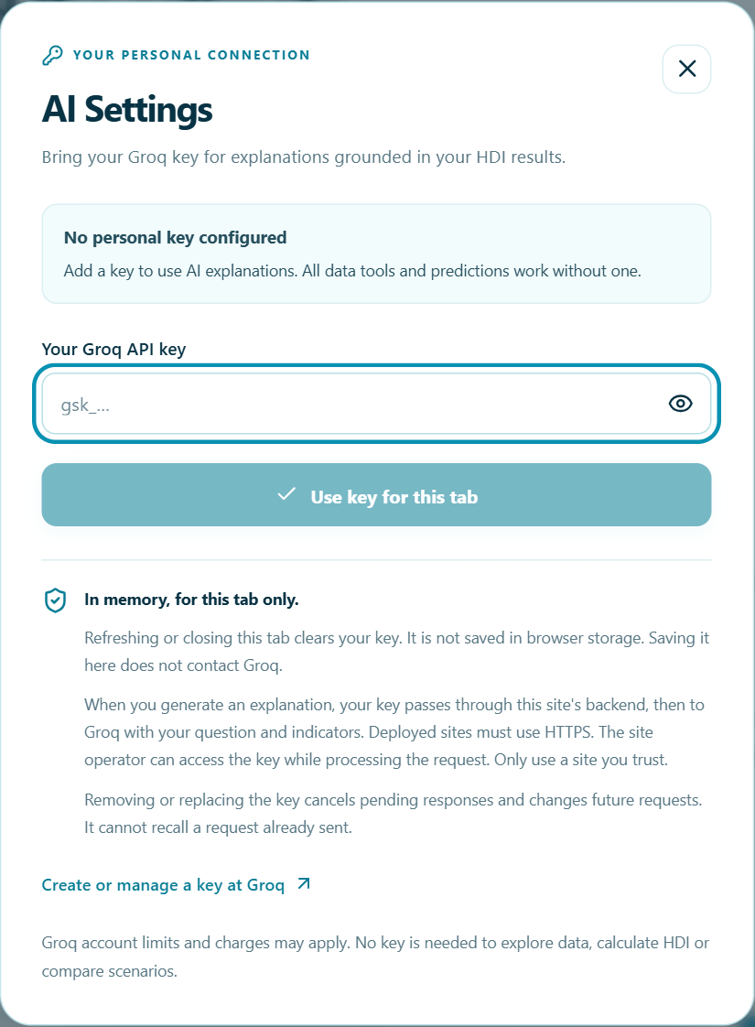
Figure 8 Personal-key settings shown without a credential
AI Settings provides masked entry, optional show/hide, change and remove controls. Saving a key means it is configured for the current tab; it does not verify provider access. Only an explicit explanation request sends it through this site’s backend to Groq. Refresh clears the key.
The hosting operator receives the credential while processing that operation, so visitors should use only trusted HTTPS sites. A missing, invalid or rate-limited key leaves the numerical tools usable. Mobile navigation, keyboard dismissal, light and dark themes and reduced motion are included in the recorded browser checks.

CHAPTER 8: CONCLUSION AND FUTURE SCOPE

8.1 Conclusion
The HDI Prediction and Analytics System combines published-data exploration, transparent numerical inference, scenario comparison and optional language-based explanations in a single public website. Its principal contribution is a reproducible educational workflow that makes the distinction between source observations and calculated results visible.
The selected linear model reconstructs HDI from the four same-year component indicators with a recorded held-out MAE of 0.004404 and R² of 0.998183. The direct formula provides an essential reference and is more appropriate when the defined components are known. These results support an index-reconstruction demonstration rather than a forecasting or causal-policy claim.
Shared validation and inference, exported parameters, country-separated evaluation, parity fixtures and browser tests connect the scientific artifacts to the application. The optional personal-key AI flow preserves numerical functionality when provider access is unavailable.

8.2 Future scope
1. Add a reviewed data-refresh process with release/version tracking and revalidation of transformed indicators.
2. Study forecasting as a separate task using lagged inputs, forward validation and appropriate temporal baselines.
3. Expand human accessibility and device testing, including screen-reader workflows and varied network conditions.
4. Measure hosted latency, concurrency and failures; introduce distributed abuse controls if public usage requires them.
5. Evaluate explanation quality systematically while preserving the distinction between generated prose and verified numerical facts.
Future capabilities should be evaluated on their own evidence. Adding complexity alone does not establish improved reliability or scientific validity.

CHAPTER 9: APPENDIX

9.1 Project links
Dataset Link:
https://hdr.undp.org/data-center/documentation-and-downloads
GitHub Repository:
https://github.com/meenamahanth/HDI-Prediction-Analytics-System
Project Demo Link (Deployed Website):
https://hdi-intelligence.vercel.app/

9.2 Reproducing the application
Use Node.js 24.x. From the repository root, enter the application folder, install the locked dependencies and start the local server. The browser address is http://127.0.0.1:5173. Python is needed only for the separate training workflow.
cd "8. Project Demonstration"
npm ci
npm run dev
Relevant verification commands are npm run typecheck, npm run lint, npm test, npm run build, npm run test:browser and npm run test:production. The browser checks require Google Chrome. A production check requires generated build assets.

9.3 Deployment configuration
Table 19 Vercel deployment settings
Setting | Value
Root directory | 8. Project Demonstration
Framework and runtime | Vite; Node.js 24.x
Install and build | npm ci; npm run build
Output directory | dist
APP_ORIGIN | https://hdi-intelligence.vercel.app (exact production HTTPS origin, without trailing slash)
ALLOW_OWNER_AI | false for public personal-key access

The API function imports the shared inference module and reads the included model JSON. A shared server Groq key is not required for public personal-key access. The deployed website is available at https://hdi-intelligence.vercel.app/; a genuine provider request with a personal key should be verified on that deployment.
Environment files must remain private and be excluded from shared archives. The example environment file contains placeholders. Ignoring or deleting an exposed credential does not revoke it; replacement must be performed through the credential provider.

9.4 References and evidence
[1] United Nations Development Programme. Human Development Report 2025, Technical Note 1: Human Development Index. The source defines the dimension goalposts and geometric aggregation used by the formula reference.
https://hdr.undp.org/sites/default/files/2025_HDR/hdr2025_technical_notes.pdf
[2] United Nations Development Programme. Documentation and downloads; HDR 2025 composite-index time series. Source observations and indicator definitions.
https://hdr.undp.org/data-center/documentation-and-downloads
[3] HDI Prediction and Analytics System repository. Model card; evaluation.json; model.json; shared/inference.mjs; ml/train.py; and the verification record in folder 6. These files supply the implementation, numerical metrics and recorded test evidence.
https://github.com/meenamahanth/HDI-Prediction-Analytics-System
[4] Vercel. Vite framework deployment documentation. Hosting target and project configuration reference.
https://vercel.com/docs/frameworks/frontend/vite
[5] Groq. API documentation. Optional explanation service accessed with a visitor’s personal credential.
https://console.groq.com/docs

9.5 Program outcomes
Program Outcomes (POs):
Engineering graduates will be able to:
1. Engineering Knowledge: Apply the knowledge of mathematics, science, engineering fundamentals, and specialized disciplines to solve complex engineering problems.
2. Problem Analysis: Identify, formulate, review research literature, and analyze complex problems using first principles of mathematics, natural and engineering sciences to reach well-founded conclusions.
3. Design and Development of Solutions: Design solutions for complex engineering problems and develop system components or processes that meet specific needs while considering public health, safety, cultural, societal, and environmental factors.
4. Investigation of Complex Problems: Utilize research-based knowledge and experimental methods, including data analysis, interpretation, and synthesis, to derive valid conclusions.
5. Modern Tool Usage: Create, select, and apply appropriate techniques, modern engineering, and IT tools for modeling, prediction, and analysis, with an awareness of their limitations.
6. The Engineer and Society: Apply contextual knowledge to assess societal, health, safety, legal, and cultural issues, recognizing responsibilities relevant to professional engineering practice.
7. Environment and Sustainability: Understand the environmental and societal impact of engineering solutions and demonstrate awareness of sustainable development needs.
8. Ethics: Uphold professional ethics, responsibilities, and norms in engineering practices.
9. Individual and Team Work: Function effectively as an individual and as a member or leader in diverse teams and multidisciplinary environments.
10. Communication: Communicate effectively on complex engineering activities with peers and society at large through clear reports, documentation, presentations, and interpersonal interactions.
11. Project Management and Finance: Demonstrate knowledge of engineering and management principles and apply them to manage projects and work efficiently in multidisciplinary teams.
12. Life-Long Learning: Recognize the importance of continuous learning and possess the ability to engage in independent and life-long learning amid evolving technological landscapes.
Program Specific Outcomes (PSOs):
Engineering students will be able to:
1. Data Interpretation and Modeling: Process and analyze real-world data to formulate models for prediction and forecasting.
2. Automation through Machine Learning: Apply machine learning and AI techniques to design and develop intelligent automated systems that solve practical, real-world problems.

9.6 Project proforma
Table 20 Classification of the project
 | Application | Product | Research | Review
Classification of Project | ✓
Note: Tick the appropriate category.

Project outcomes
Table 21 Internship course outcomes
Code | Outcome from the template
CO1 | Acquire technical competence in the specific domain during the training.
CO2 | Identify the problem statement based on the requirements of the industry.
CO3 | Adapt project management skills on par with industrial standards.
CO4 | Develop a system model to obtain a solution and generate a report.

9.7 Outcome mapping
Table 23 Course outcome to program outcome mapping
CO | PO1 | PO2 | PO3 | PO4 | PO5 | PO6 | PO7 | PO8 | PO9 | PO10 | PO11 | PO12 | PSO1 | PSO2
CO1 | 3 | 2 | 2 | 2 | 3 | – | – | 2 | 1 | 2 | 1 | 3 | 3 | 2
CO2 | 2 | 3 | 2 | 3 | 2 | 2 | 1 | 3 | 1 | 2 | 1 | 2 | 3 | 2
CO3 | 1 | 2 | 2 | 1 | 2 | 1 | – | 2 | 2 | 2 | 3 | 2 | 1 | 2
CO4 | 3 | 3 | 3 | 3 | 3 | 2 | 1 | 3 | 2 | 3 | 2 | 3 | 3 | 3
Avg. | 2 | 3 | 2 | 2 | 3 | 2 | 1 | 3 | 2 | 2 | 2 | 3 | 3 | 2

Note: Each course outcome is mapped to the POs and PSOs on a scale of 1, 2 or 3 according to the level of mapping:
1 – Slightly (Low) mapped,
2 – Moderately (Medium) mapped,
3 – Substantially (High) mapped.

